A case in Justice Court that is moved to District Court should not have a new case in LegalServer. You need to add the new court with District court name and District case number. Both Justice and District case numbers will be recorded for tracking purposes and accuracy.
Adding court or how to add a District Court case number when a Justice Court case is bound over to District Court.
In order to keep Justice Court and District Court case numbers intact we have the user add the District Court as a new Jurisdiction.
Review the current entries in the Litigation Tab to see Courts and Cases entered initially.
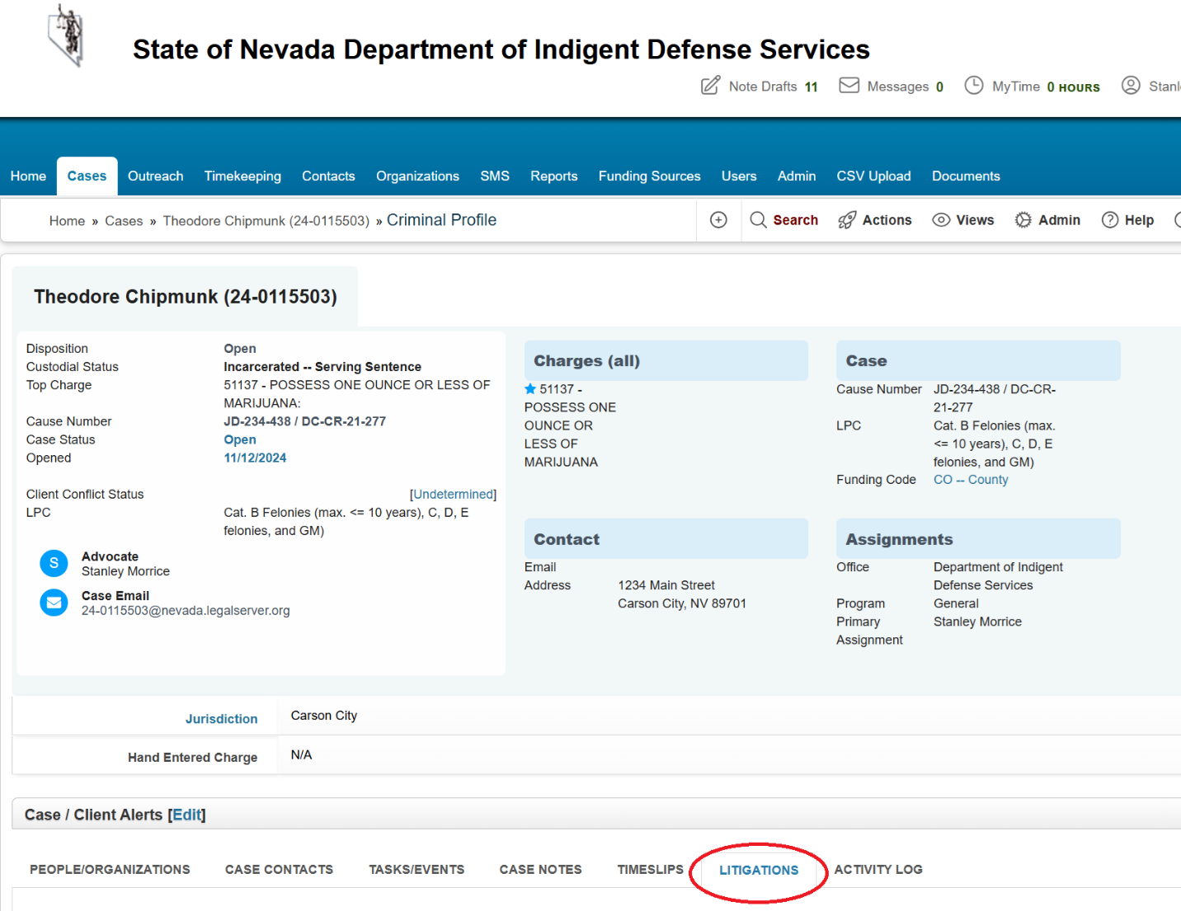

In this example we have two courts listed. One for Justice Court and another one for District Court.
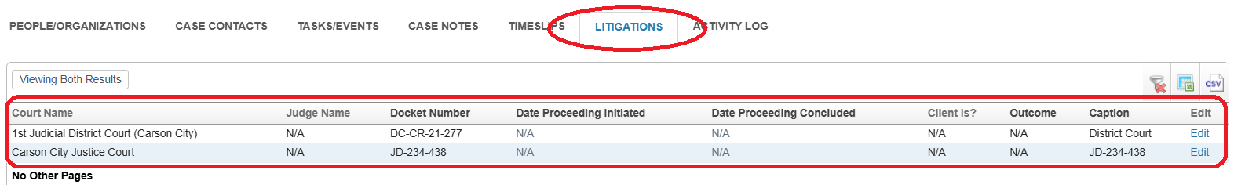
This way we can keep track of case numbers and the changes once bound over.
How to add a court when a case is bound over to District Court.
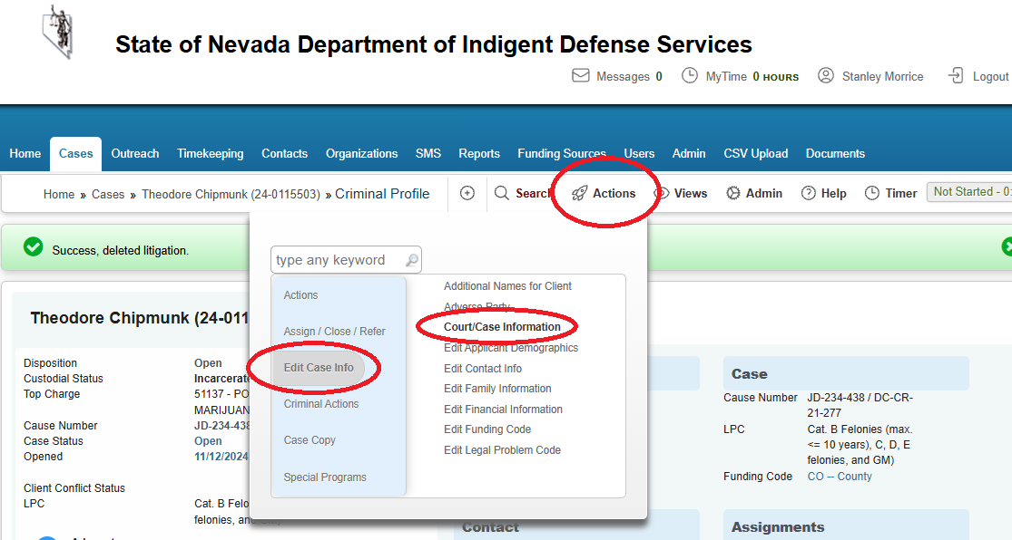
Add Court Info.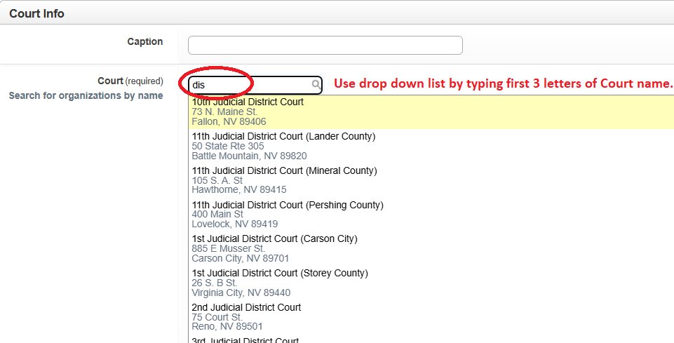
Add Case Title and Case numbers for both Justice and District.
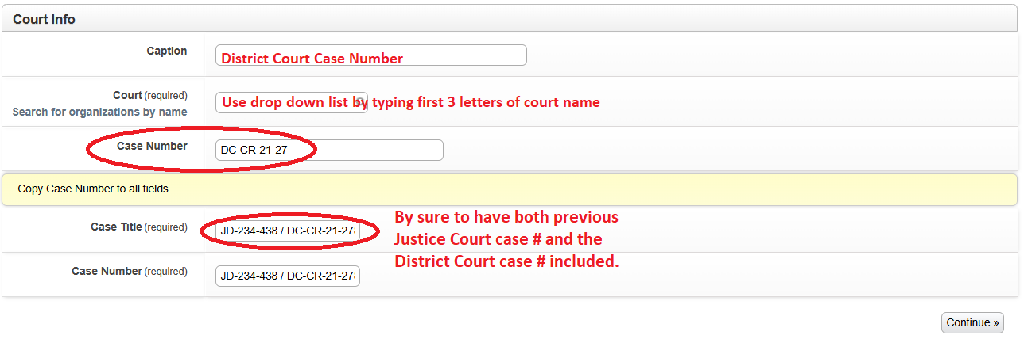
Verify the added information under Litigation TAB.
